1. **When we started the application the UI appears as follows:**

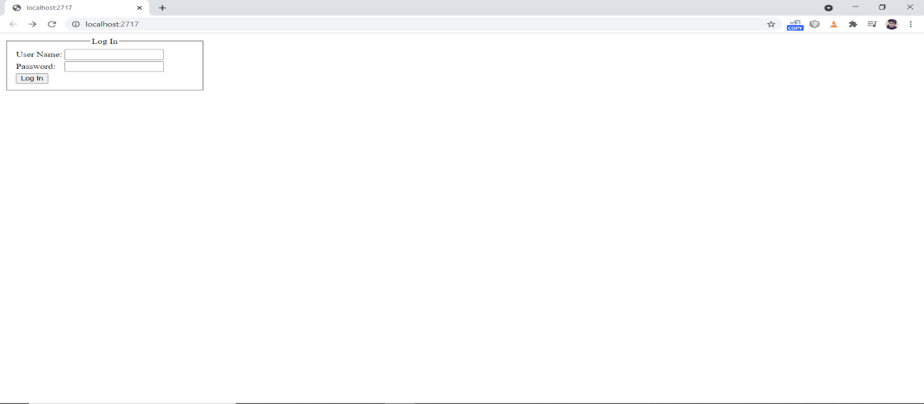

1. **Enter Valid credentials:**

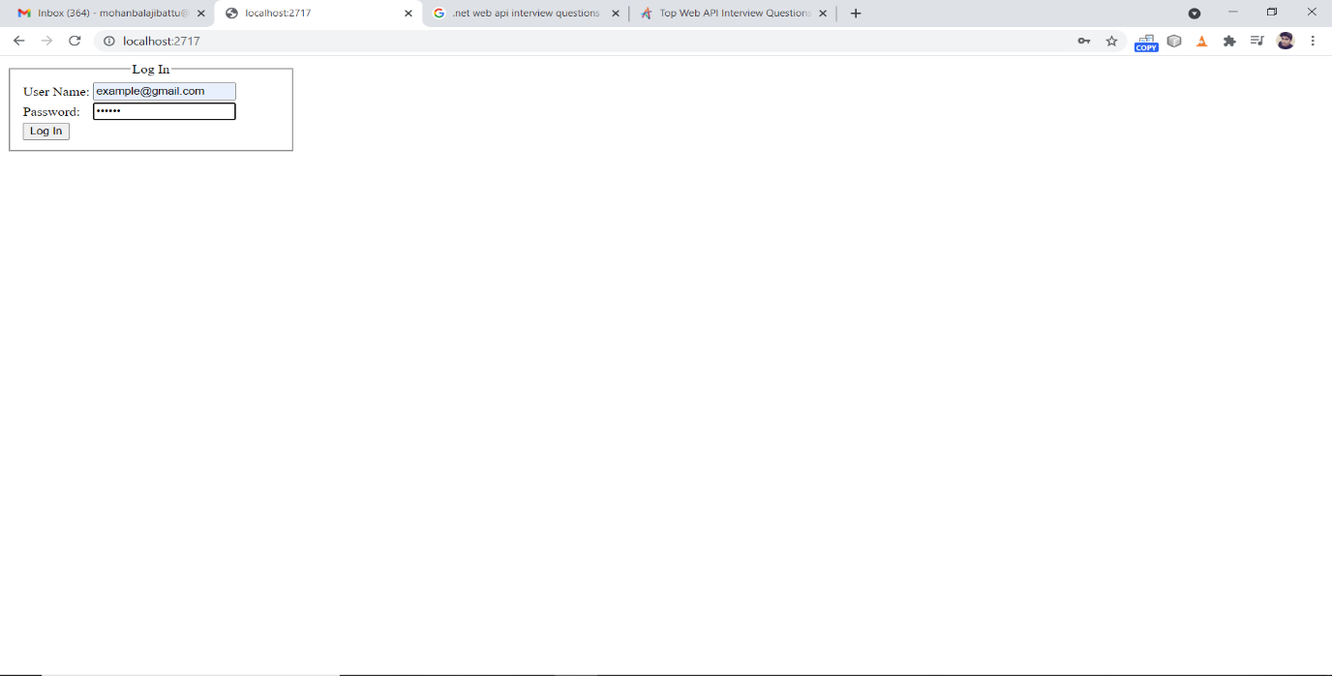

**3.If credentials are correct it will appear as below.**

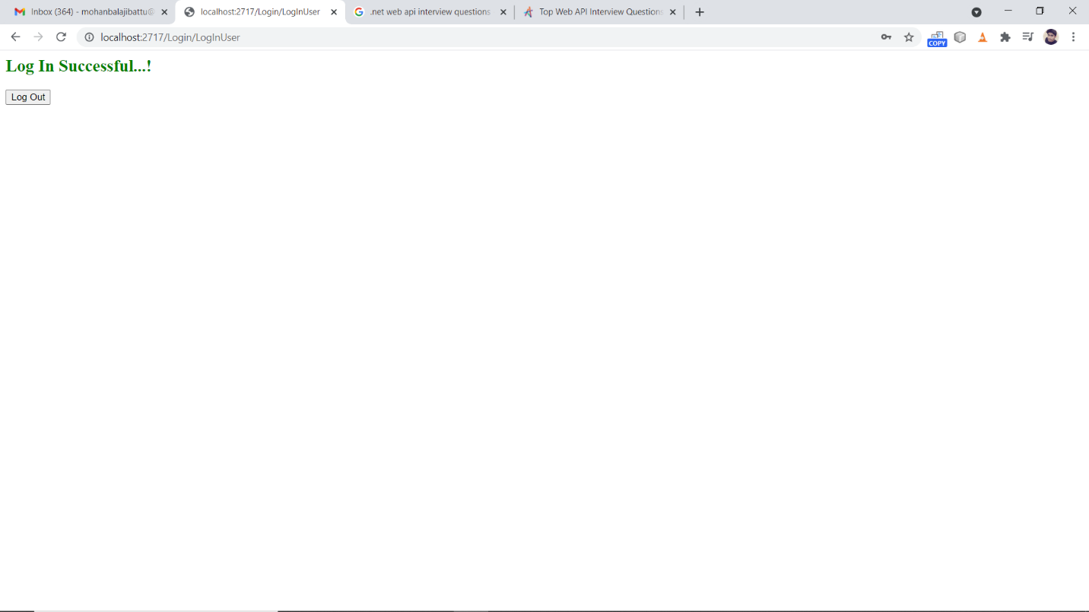

**4.If credentials are wrong it will displays as follows.**

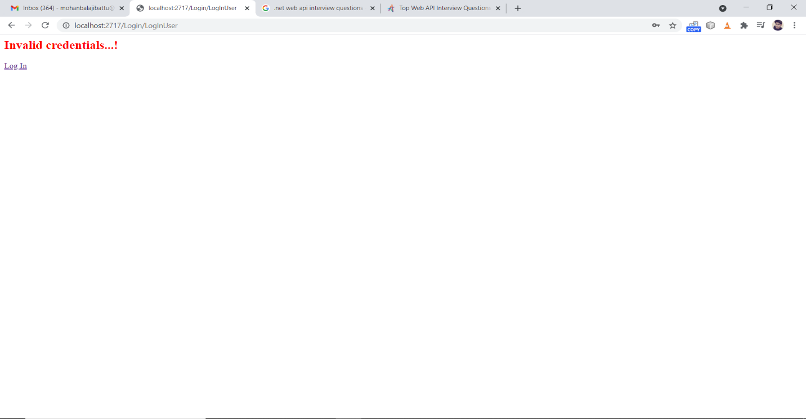

**5.Database login table**

